Logbook 6
Name: | Kaung Linn Aung
Project Name | Autonomous Underwater Robot (AUV) for Submerged Environment Scanning and Video Recording
Week Date: | Part B -Meeting 6 of 8
(The above information is for you to keep track of which week this log is applicable for. This information is not required in the online logbook as the system will find your name, your supervisor’s name, and take the submission date, automatically. You must submit the online log in the relevant week. Logs cannot be backdated to missed weeks.)

Meeting date:  (please note if no meeting is planned this week) | Date and day  7 Oct 2026
Work Undertaken this week:  Not more than 500 words | State the engineering work done from first meeting on 23 October till today 7 Oct.  - CAD model completed, and the ballast and rudder parts printed.  Ballast system assembly (syringes, N20 motor, lead screw) underway with anticipated completion on 12 Oct.  - Tested the MPU-6050 IMU with the STM32 Nucleo-F411RE on I²C. The device was found at address 0x68 and returned WHO_AM_I = 0x68 which is a valid MPU-6050. A live dashboard on the PC was showing the accelerometer, gyroscope, temperature and orientation data. Pitch was measured at approximately 53° with the board stationary and the gyro rates were found to be near zero. The fused estimate roll is 24° which is not correct, the raw accelerometer roll is approximately 1°, so need to investigate the roll calculation.
Problems encountered:  (Not more than 500 words | What are the challenges to your project you foresee and how are you going to address it?  - Servo specs: the usable travel and stall current should be checked on the bench before designing the linkage.  - Roll mismatch between fused estimate and raw accelerometer. Plan: check the axis mapping and fusion code, and test on a flat table.  - Gyro offset when idle. Plan: start-up calibration and use a complementary filter.
Tasks agreed for upcoming week before the next meeting | What are the key tasks you would like to focus from now till end of 4th meeting on 18 Nov 2026.  Update your Project Gantt chart and upload to Github  - Complete ballast system assembly and bench test.  - Test MG90S servos (travel and stall current) on bench.  - Complete rudder system assembly and test.  - Update the Gantt chart and upload it to Github.
Figures:  (Upload image files in the online Log Form, but feel free to keep notes here about which images you intend to upload. Use “Figure Caption” information as the filenames, e.g., “Figure 1 – A screenshot of the initial constrained Sketch in CATIA.jpg”) | Upload and update your document in Github  Your Github link:  Updated Github Link  https://github.com/IceBerg-coder/IMP-AUV-Project  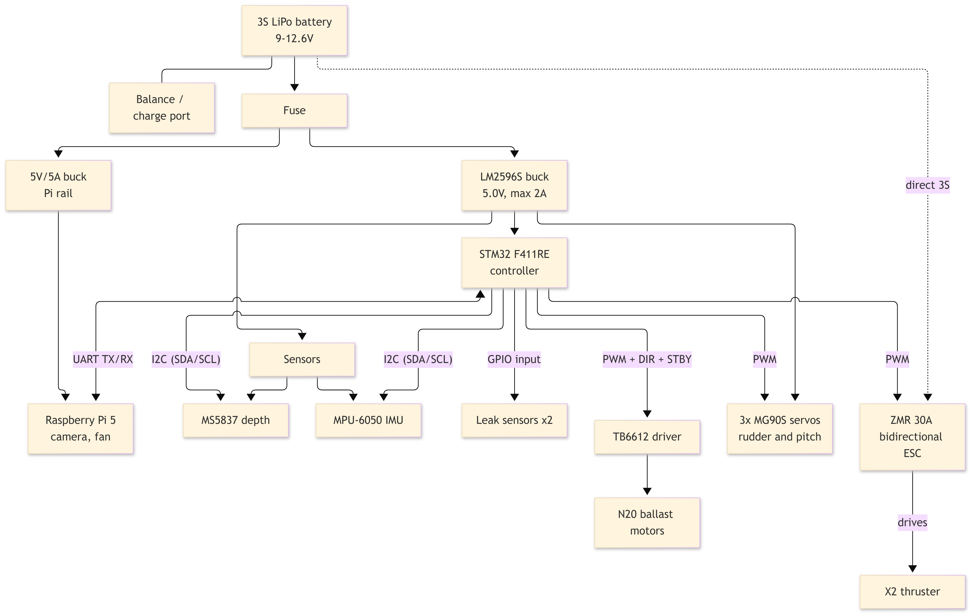Figure 1: Hardware Block Diagram  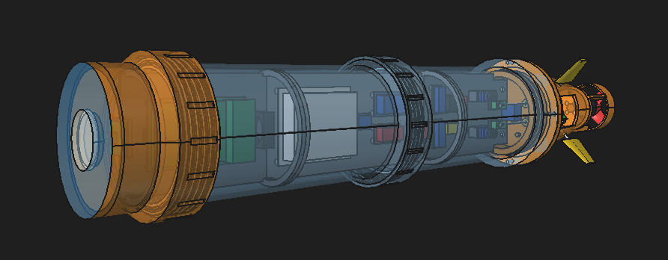Figure 2: Updated Prototype CAD model

